**Industry Grade Project I task description**

**Task 1**

1. Downloaded code from repo, save code in VS-code. Installed Java and Maven in my local laptop. Also installed maven and java plugin in VS-code.
2. Build the source code, by running mvn compile, test and package.
3. Code build and pushed to my Github repository.

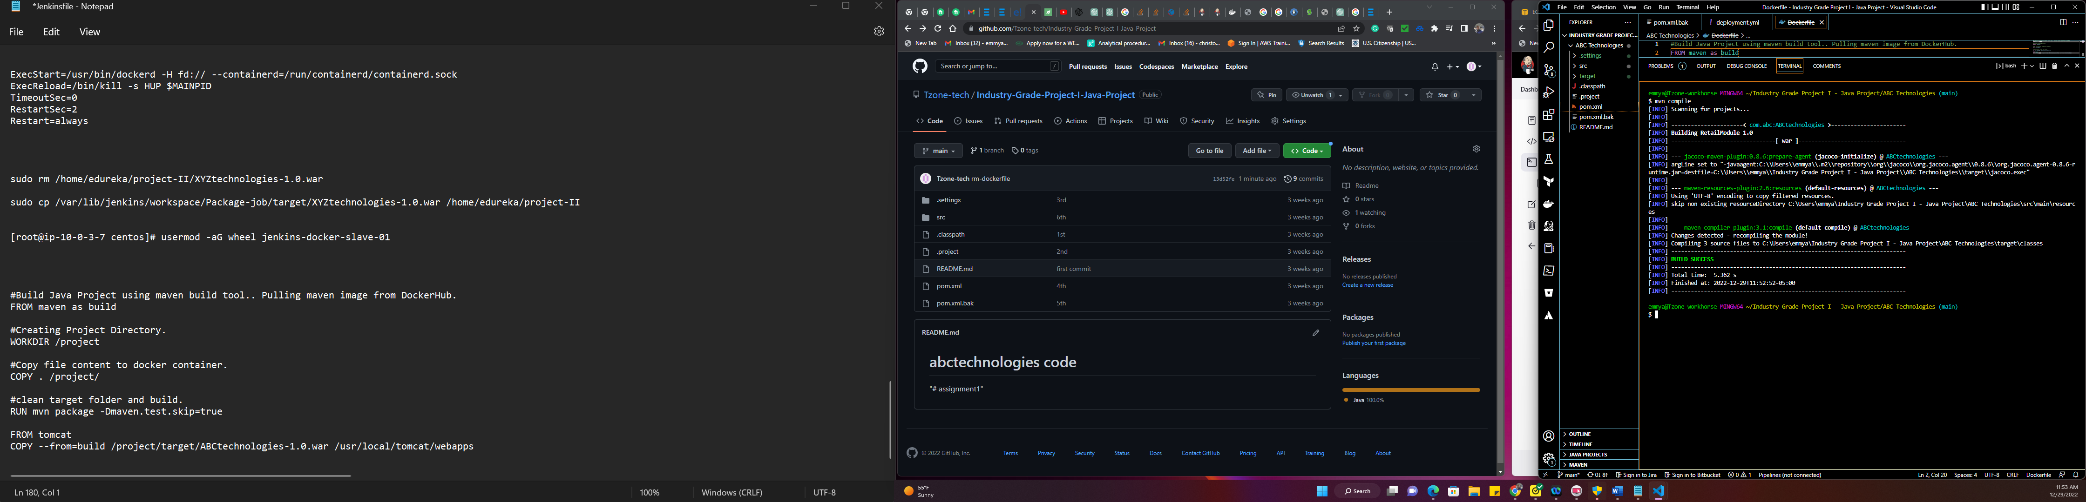

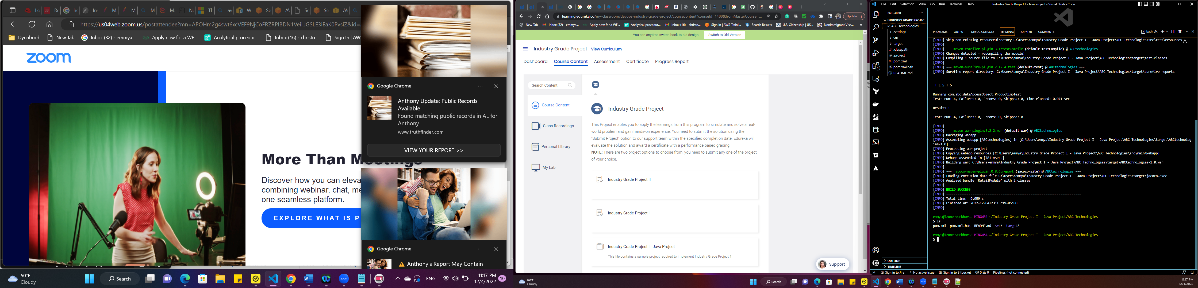

Compile screen shot on my laptop

**Task 2**

1. Login into Jenkins, clicked on new pipeline, chose Freestyle project, save. In source code management, click git, inputted my git repo link, credential is not needed since it’s a public repository. Left the branches to build at any.

For the build steps, picked Invoke top level Maven targets, chose maven version and goals as compilation saved and built the job.

The same process for repeated for the test and package job.

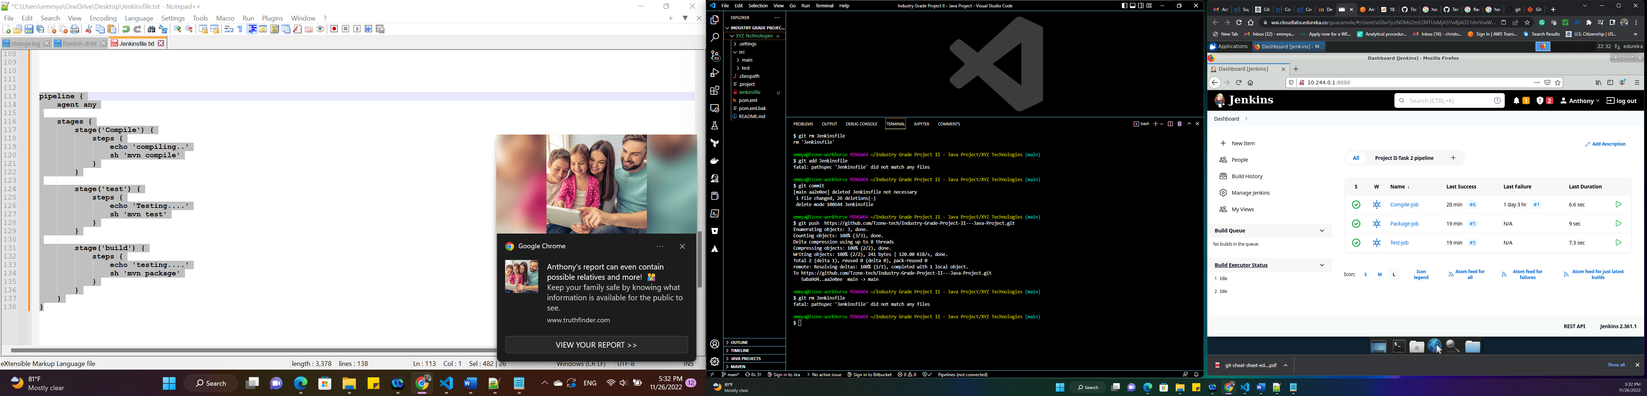

Compile, Test and Package job

**CI/CD Pipeline**

Before creating the pipeline using Build pipeline plugin, I linked all the jobs together. I configured the pipeline to run automatically when there is git push into the repository by configuring webhook on the repository.

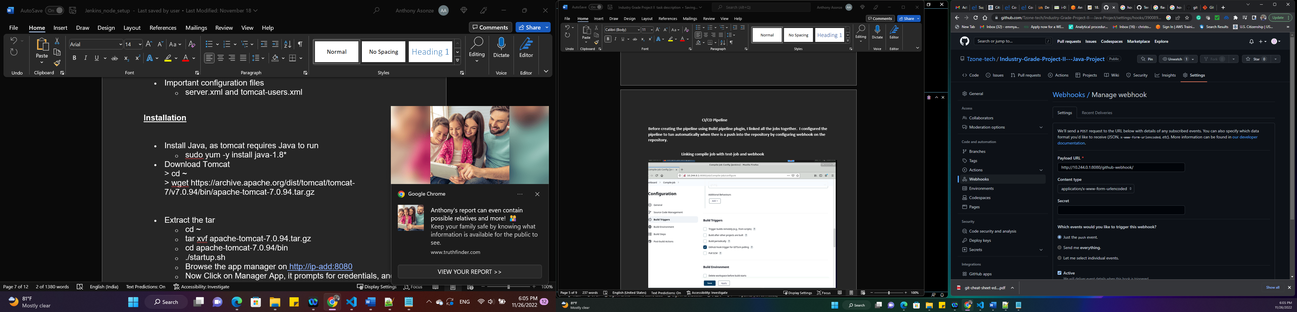

**Linking compile job with test-job and webhook**

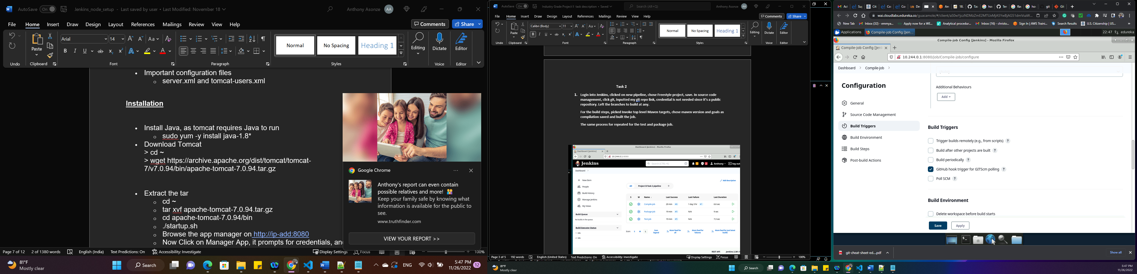

**Linking test-job with package- job**

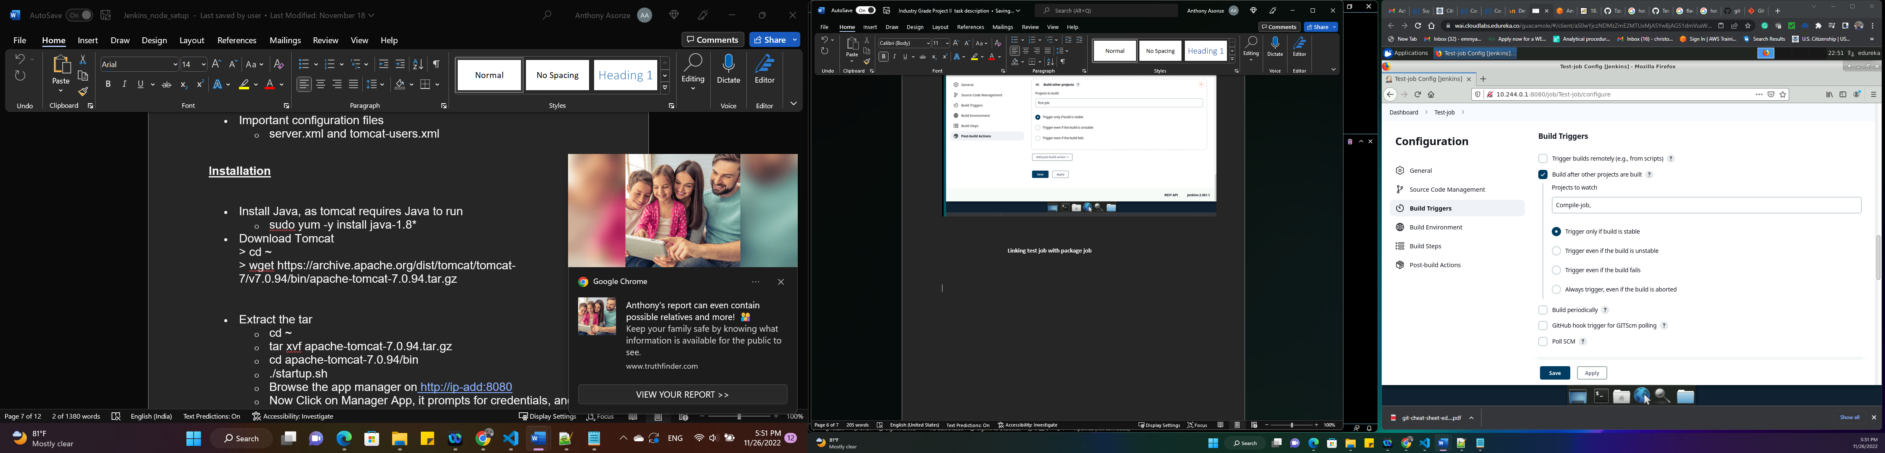

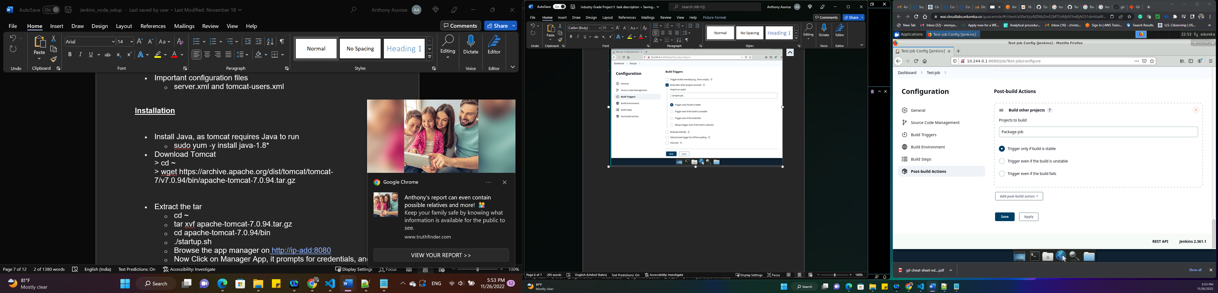

**Linking test-job with Package**

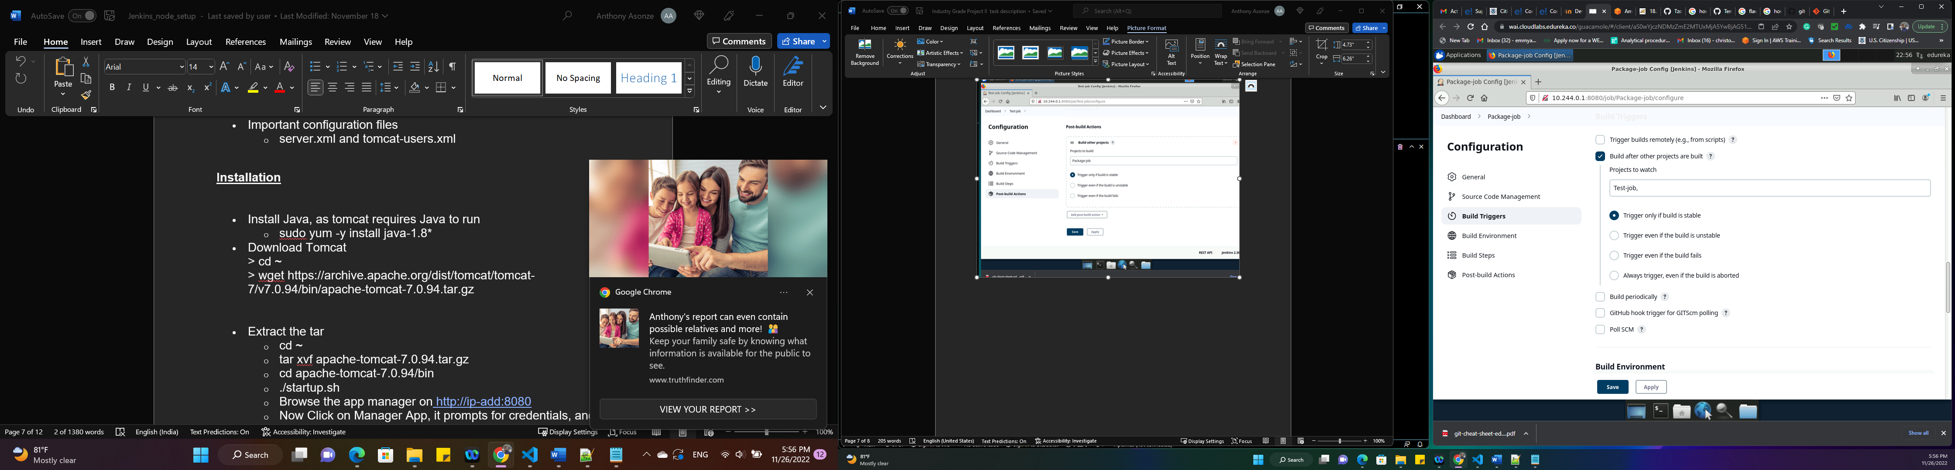

Creating the pipeline, I installed the build pipeline plugin, compile-job was automatically populated as the initial job, the no of display builds was set as one. All other configuration was left at default.

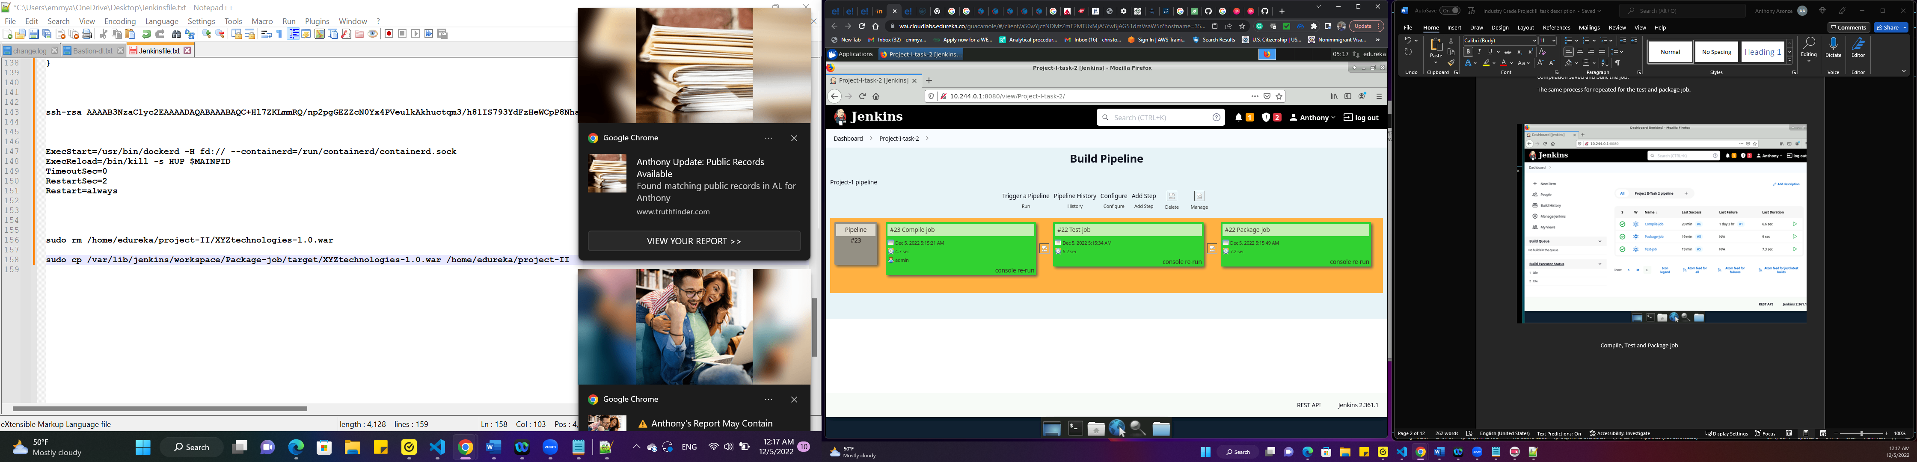

**CI/CD Pipeline**

**Task 3**

Before writing the Dockerfile, I had pull my ecomm image ( docker pull lacroit/ecomm)from docker hub into docker server.

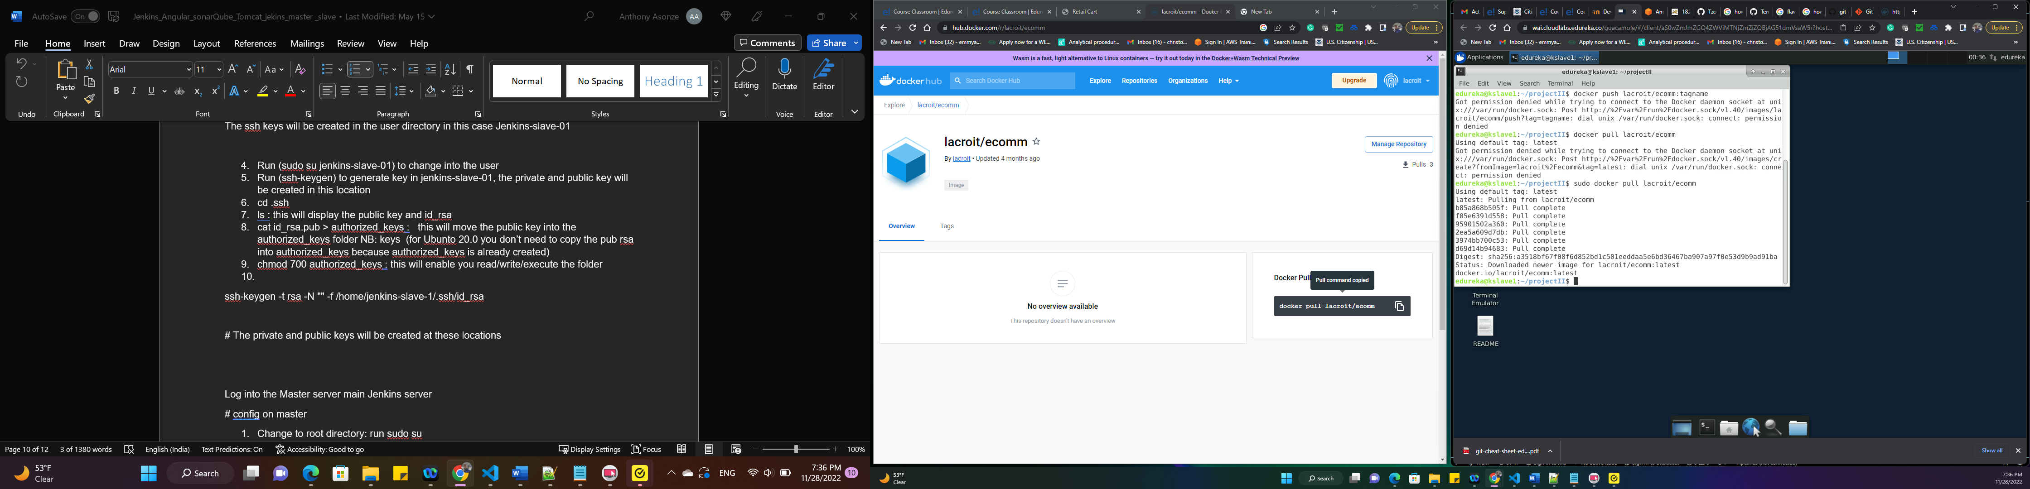

The ecomm app was

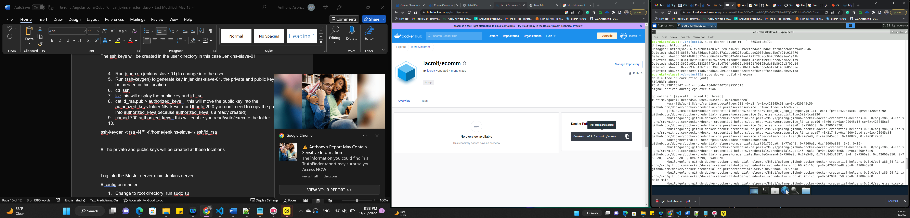

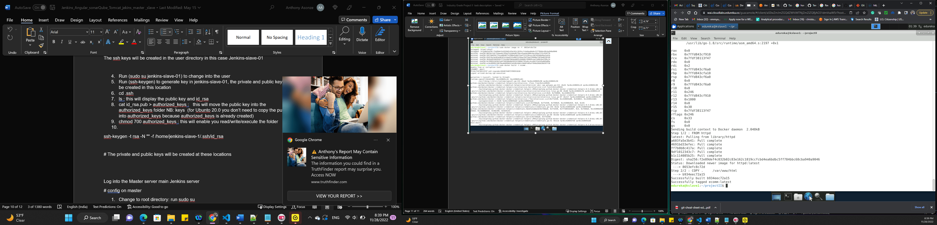

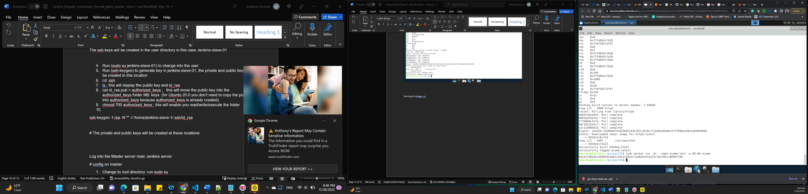

Running the image

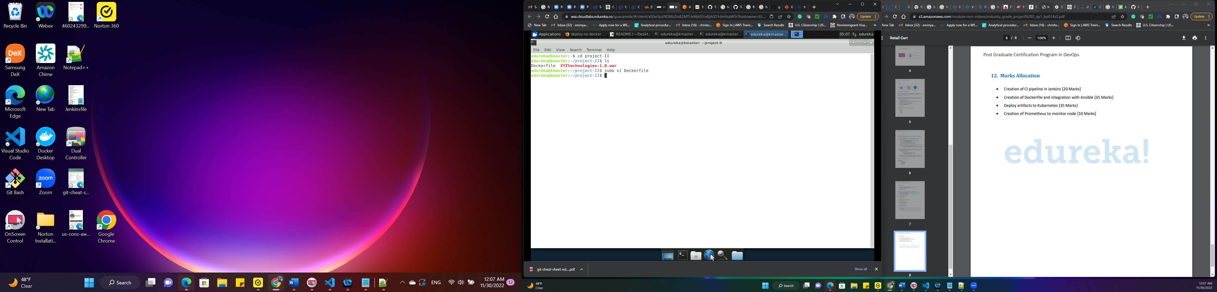

.war deployed to docker host using jenkins

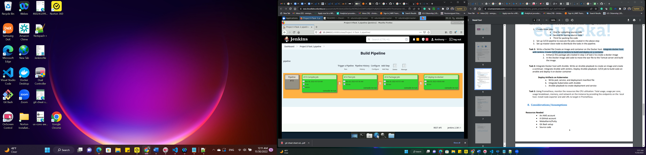

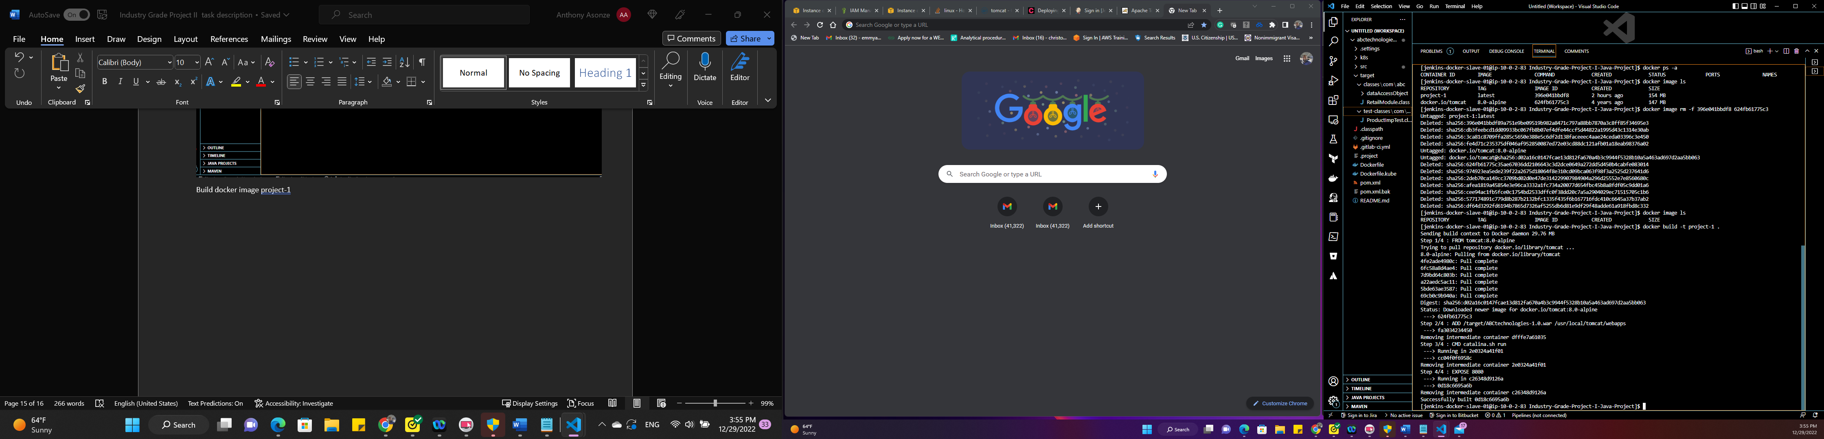

Build docker image project 1

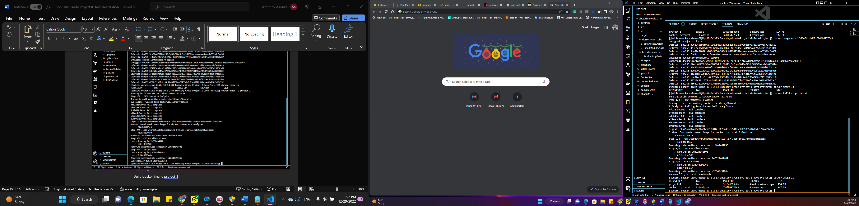

Display built image

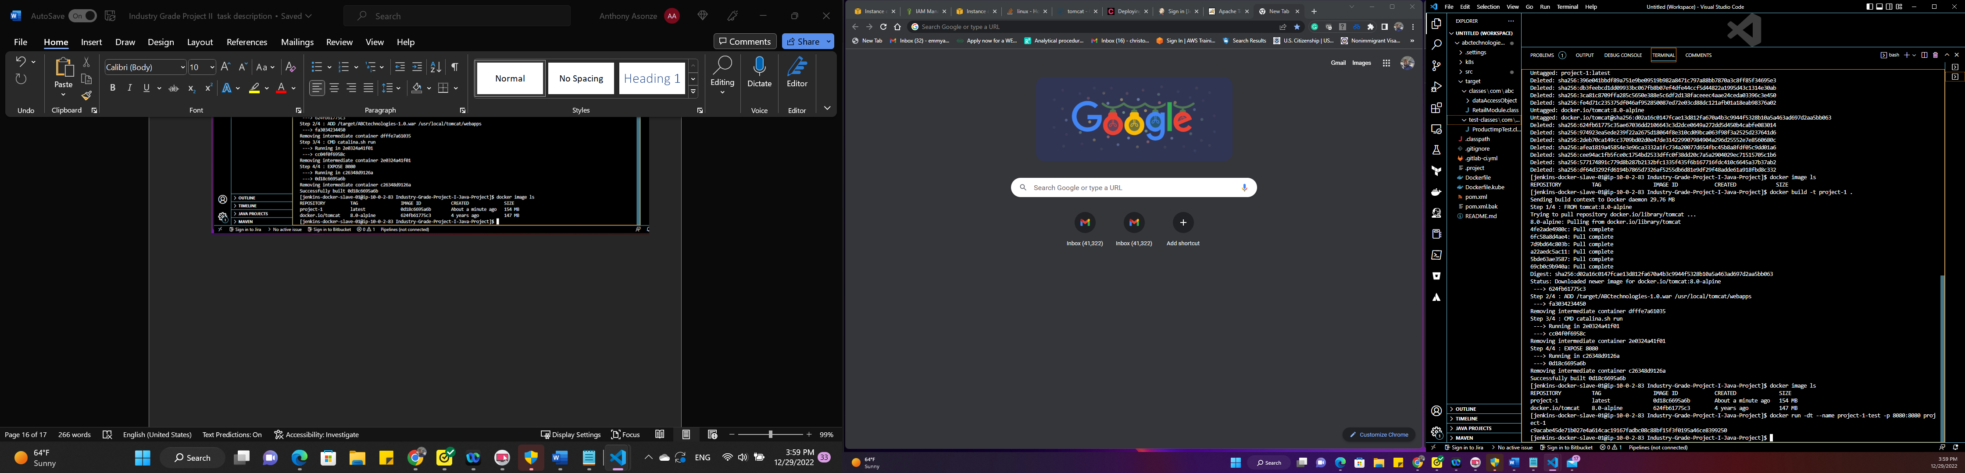

Build container

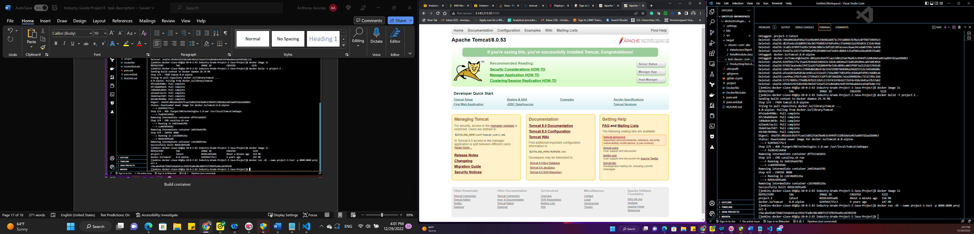

Tomcat Page

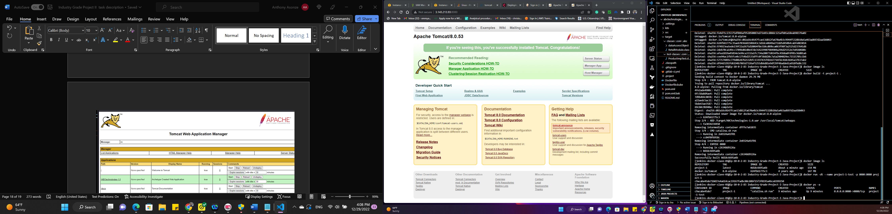

Display of created contain

Ran command to log into the tomcat container to edit the “conf/tomcat-users.xml” file and add below to tomcat user

<role rolename="manager-gui"/>

<user username="tomcat" password="s3cret" roles="manager-gui"/>

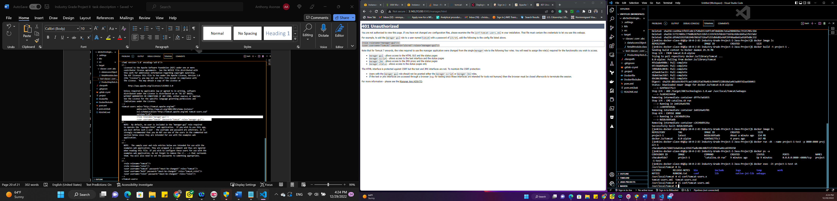

Command into tomcat container

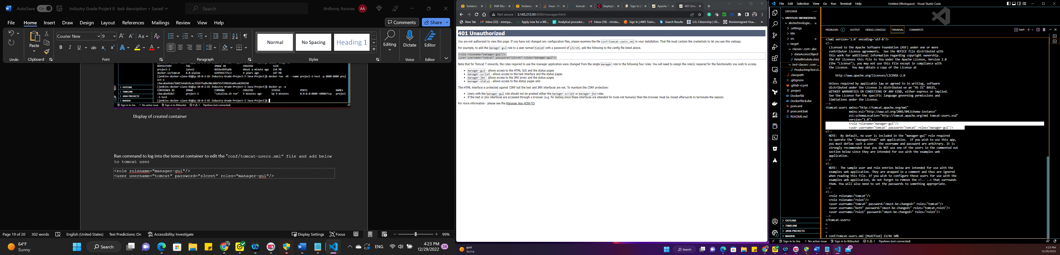

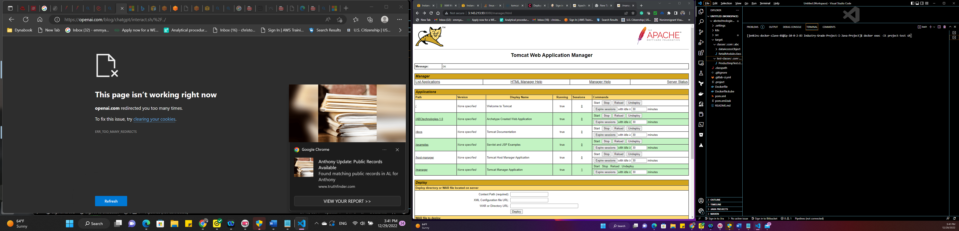

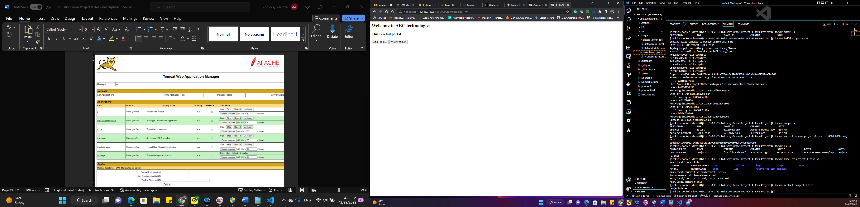

ABC technology portal

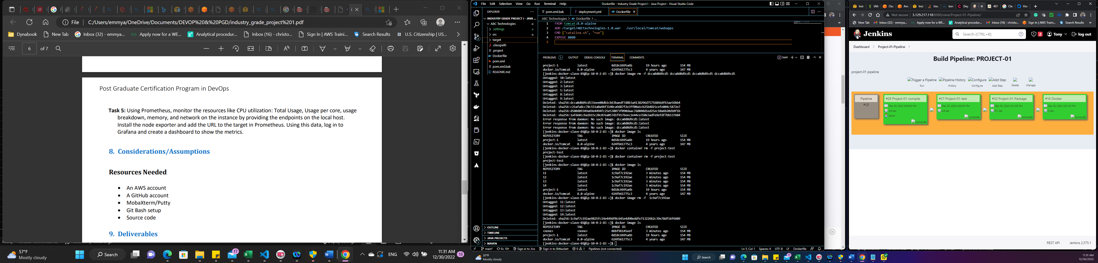

Pipeline to build and deploy container

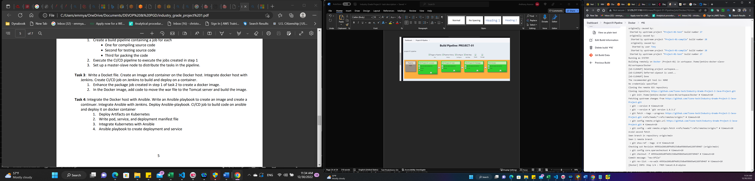

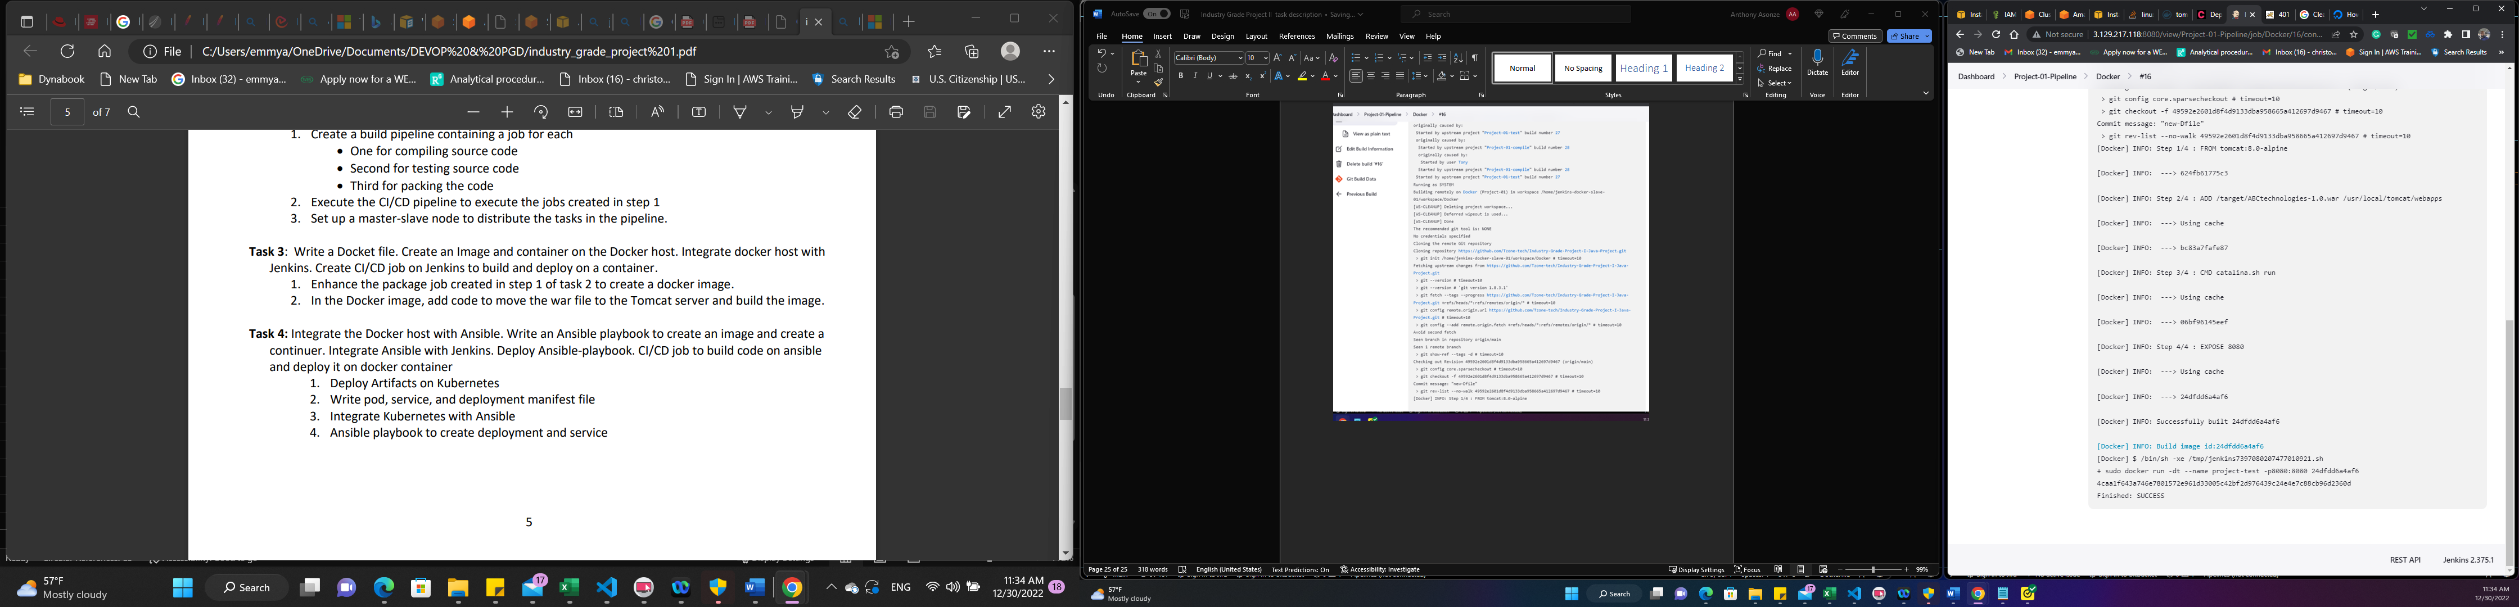

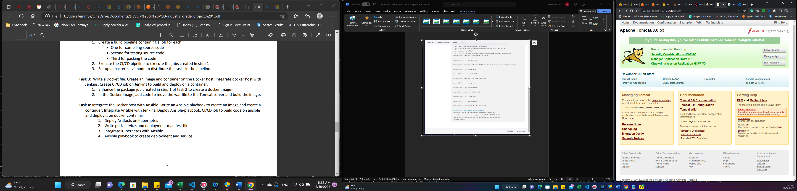

Tomcat webpages build with Jenkins and Docker

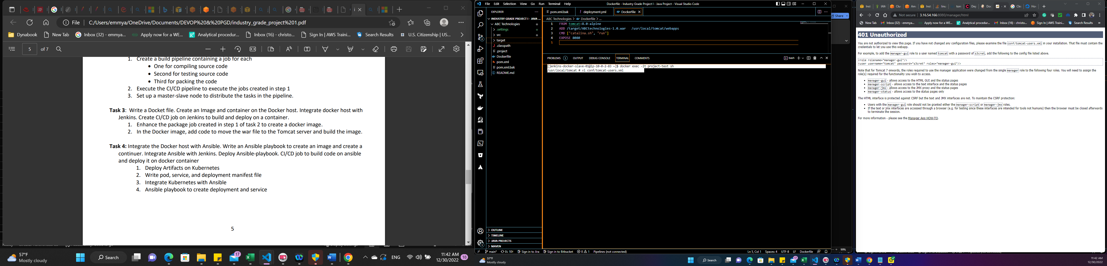

Command to log into container and edit conf/tomcat-users.xml file



TASK 4